**Hearing Aids:**

Hearing aids come in all shapes and sizes. Hearing aids are constantly changing – and shrinking.

There are different sizes and styles available. The sizes and styles of the recommended hearing aids depends on the degree of your hearing loss, your lifestyle and preferences.

**Different Styles of hearing aids:**

**Receiver-in-canal (RIC) hearing aid:**

A Receiver-in-canal hearing aid looks very similar to a Behind-the-ear hearing aid. A unique difference is that the hearing aid microphone is placed inside the ear canal.

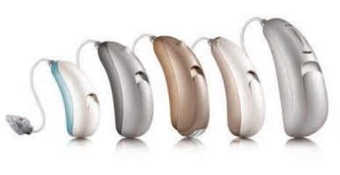

**In-the-ear (ITE) hearing aid:**

All the parts of the hearing aid are contained in a shell that is placed in the ear canal and fills the outer ear opening.

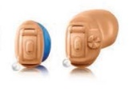

**Behind-the-ear (BTE) hearing aid:**

The hearing aid rests behind the ear. A BTE hearing aid is the most versatile hearing instrument and may be fitted to all hearing losses.

